**GEOINFORMATICS FOR DISASASTER MANAGEMENT (LAB 1)**

|  |
| --- |
| If you are new to ArcGIS, first look at:  <http://desktop.arcgis.com/en/arcmap/10.4/get-started/introduction/a-quick-tour-of-arcmap.htm>  <http://desktop.arcgis.com/en/arcmap/10.4/get-started/introduction/a-quick-tour-of-arccatalog.htm> |

**Basic Vector Styling**

To create a map, one has to style the GIS data and present it in a form that is visually informative. There are a large number of options available in QGIS to apply different types of symbology to the underlying data. In this tutorial, we will explore some basics of styling.

**Overview of the task**

We will style a vector layer to show population distribution in different wards of Zanzibar.

**Data:**

Unguja shapefile

**Procedures:**

* Start **ArcMap** with a new empty map.
* Click on the **Add Data** button.
* Browse the location where Unguja.shp is located and click Add.
* The shapefile contained is now loaded and you can see the default style applied to it.

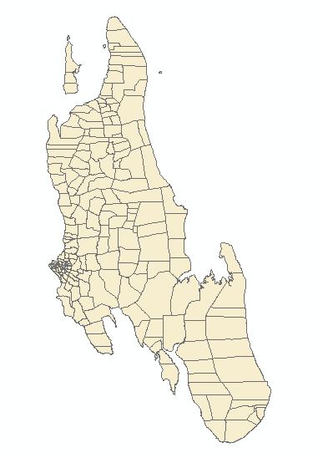

* Right click on the layer name and select Open Attribute Table.

**Explore the different attributes.**

* To style a layer, we must pick an ***attribute*** or a ***column*** that would represent the map we are trying to create. Since we want to create a layer represting population distribution, the field ***2012_pop_T*** is the attribute we want to use in styling.

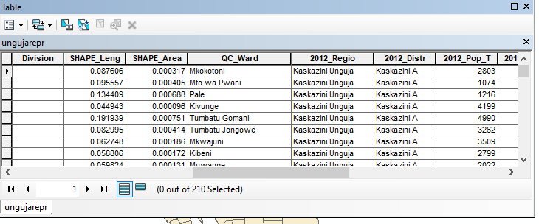

* Close the attribute table. Right click on the layer again and choose Properties, and then click symbology tab.
* The various styling options are located in the symbology tab of the Properties dialog. This includes Single Symbol, Categorized, Graduated, Quantile , Charts and multiple attributes. We will explore the first three in this tutorial.
* Select features, and then select Single Symbol. This option allows you to choose a single style that will be applied to all the features in the layer. Since this is a polygon dataset, you have two basic choices. You can ***fill*** the polygon, or you can style with only ***outline***. You can choose the  ***green fill*** and click **Apply** and then click **OK.**
* Now you will see a new style applied to the layer with the fill pattern you chose.

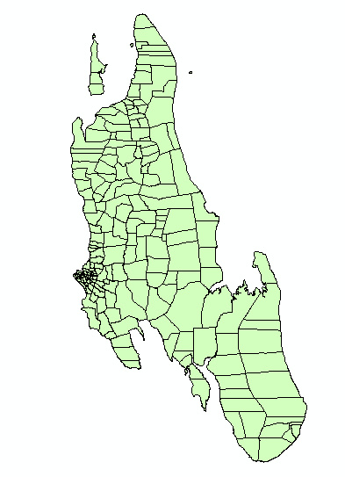

* You will see that this Single Symbol style isn’t useful in communicating the population distribution data we are trying to map.
* Let us explore another styling option. Right-click the layer again and choose Properties. This time choose Categorized from the Style tab. Categorized means the features in the layer will be shown in different shades of a color based on unique values in an attribute field. Choose ***2012_pop_T*** value as the Column and click **Add all values** at the bottom, change the color ramp and then. **Click OK.**

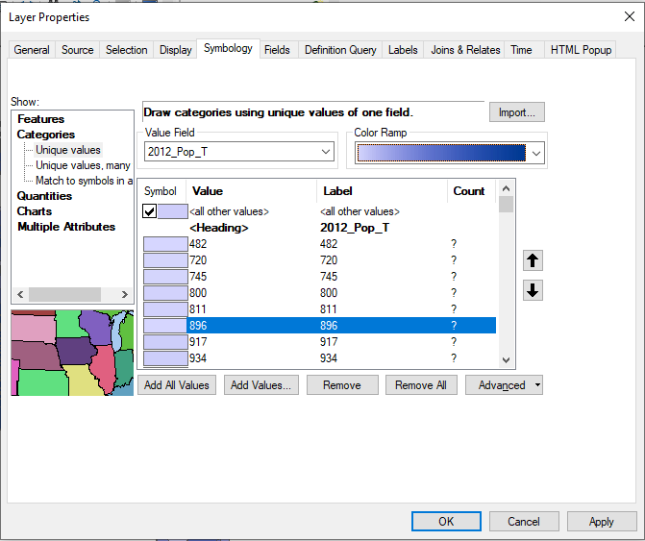

* You will see different wards appearing in shades of blue. Lighter shades meaning lower population and darker shades meaning higher population.
* This representation of the data is more useful and clearly show how population are distribution in different regions in Unguja. This would be the type of style we set out to create.

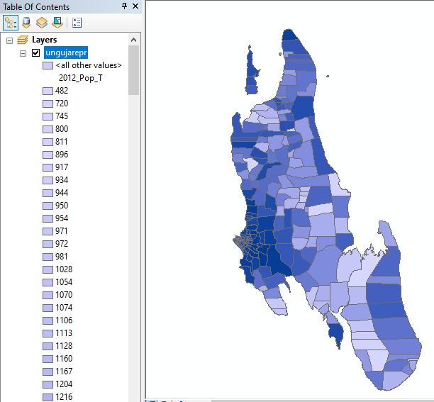

* Now, let us explore the Graduated symbology type in the Style dialog now. Graduated symbology type allows you to break down the data in a column in unique ***classes*** and choose a different style for each of the classes. We can think of classifying our population distribution data into 3 classes, ***LOW***, ***MEDIUM*** and ***HIGH***.

* Choose ***2012_pop_T*** as the Column and choose 3 as the classes. you will see there are many Mode options available. Let us see the logic behind each of these modes. There are 5 modes available. Equal Interval, Quantile, Natural Breaks (Jenks), Standard Deviation and Pretty Breaks. These modes use different statistical algorithms to break down the data into separate classes.
* **Equal Interval:** As the name suggests, this method will create classes which are at the same size. If our data ranges from 0-100 and we want 10 classes, this method would create a class from 0-10, 10-20, 20-30 and so on, keeping each class the same size of 10 units.
* **Quantile** - This method will decide the classes such that number of values in each class are the same. If there are 100 values and we want 4 classes, quantile method will decide the classes such that each class will have 25 values.
* **Natural Breaks (Jenks)** - This algorithm tries to find natural groupings of data to create classes. The resulting classes will be such that there will be maximum variance between individual classes and least variance within each class.
* **Standard Deviation** - This method will calculate the mean of the data, and create classes based on standard deviation from the mean.
* **Pretty Breaks** - This is based on the statistical package R’s pretty algorithm. It is a bit complex, but the ***pretty*** in the name means it creates class boundaries that are round numbers.

To keep things simple, let’s use the Quantile method. Click Classify at the bottom

and you will see 3 classes show up with their corresponding values. **Click OK**.

***Note***

*For an attribute to be used in Graduated style, it must be a numeric field. Integer and Real values are fine, but if the attribute field type is String, it cannot be used with this styling option.*

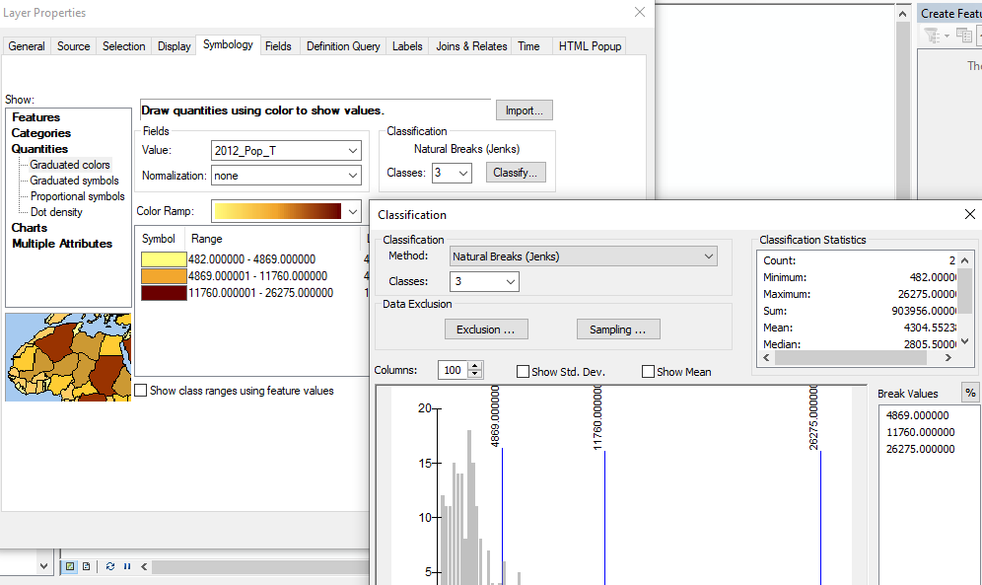

You will see a map showing regions (wards) in either of 3 colors representing average population distribution in the country.

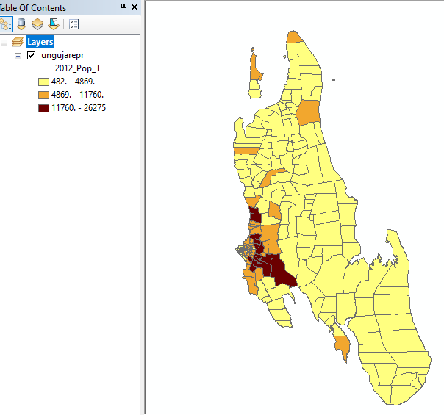

* Now you can double click on the Symbol for each of the classes and choose a different style, (There are some more styling options available). We will choose Red, Yellow and Green fill colors to indicate low, medium and high population).
* In the Symbol Selector dialog, click on Color selector

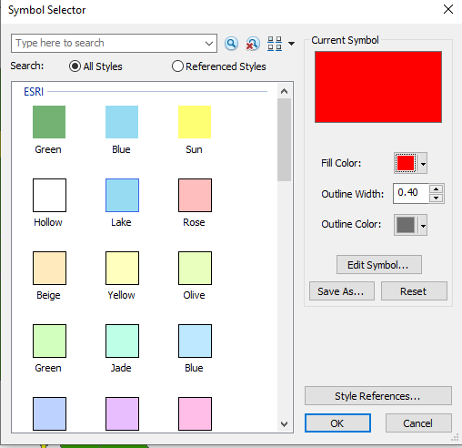

* Back in the Layer Properties dialog, you can click on the Label column next to each value and enter the text that you want to display. Similarly, you may click on the Range column to edit the selected ranges. Click OK once you are satisfied with the classes.

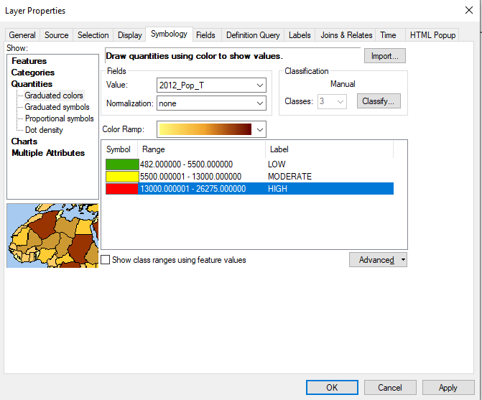

* This style definitely conveys a lot more useful map than the previous two attempts.
* There are clearly marked class names and colors to represent our interpretation of the population distribution values.

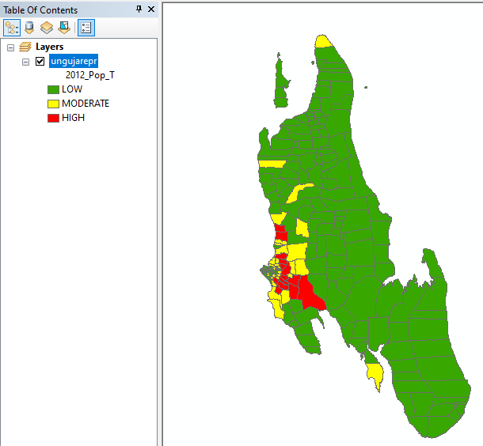

MAKING A MAP:

ArcMap provides two ways to view a map: data view and layout view.

* Data view: This is specifically for analyzing and manipulating the data

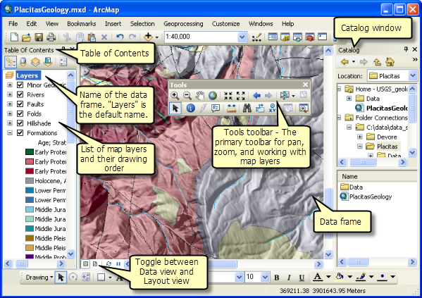

**Data View**: Data view provides a geographic window for exploring, displaying, and querying the data on your map. You work in real-world coordinates and measurements in data view.

**Layout View**: In layout view, you work with the map layout elements, such as titles, north arrows, and scale bars, along with the data frame, all of which are arranged on a page.

To create and arranging your final map, you need to use a Layout View.